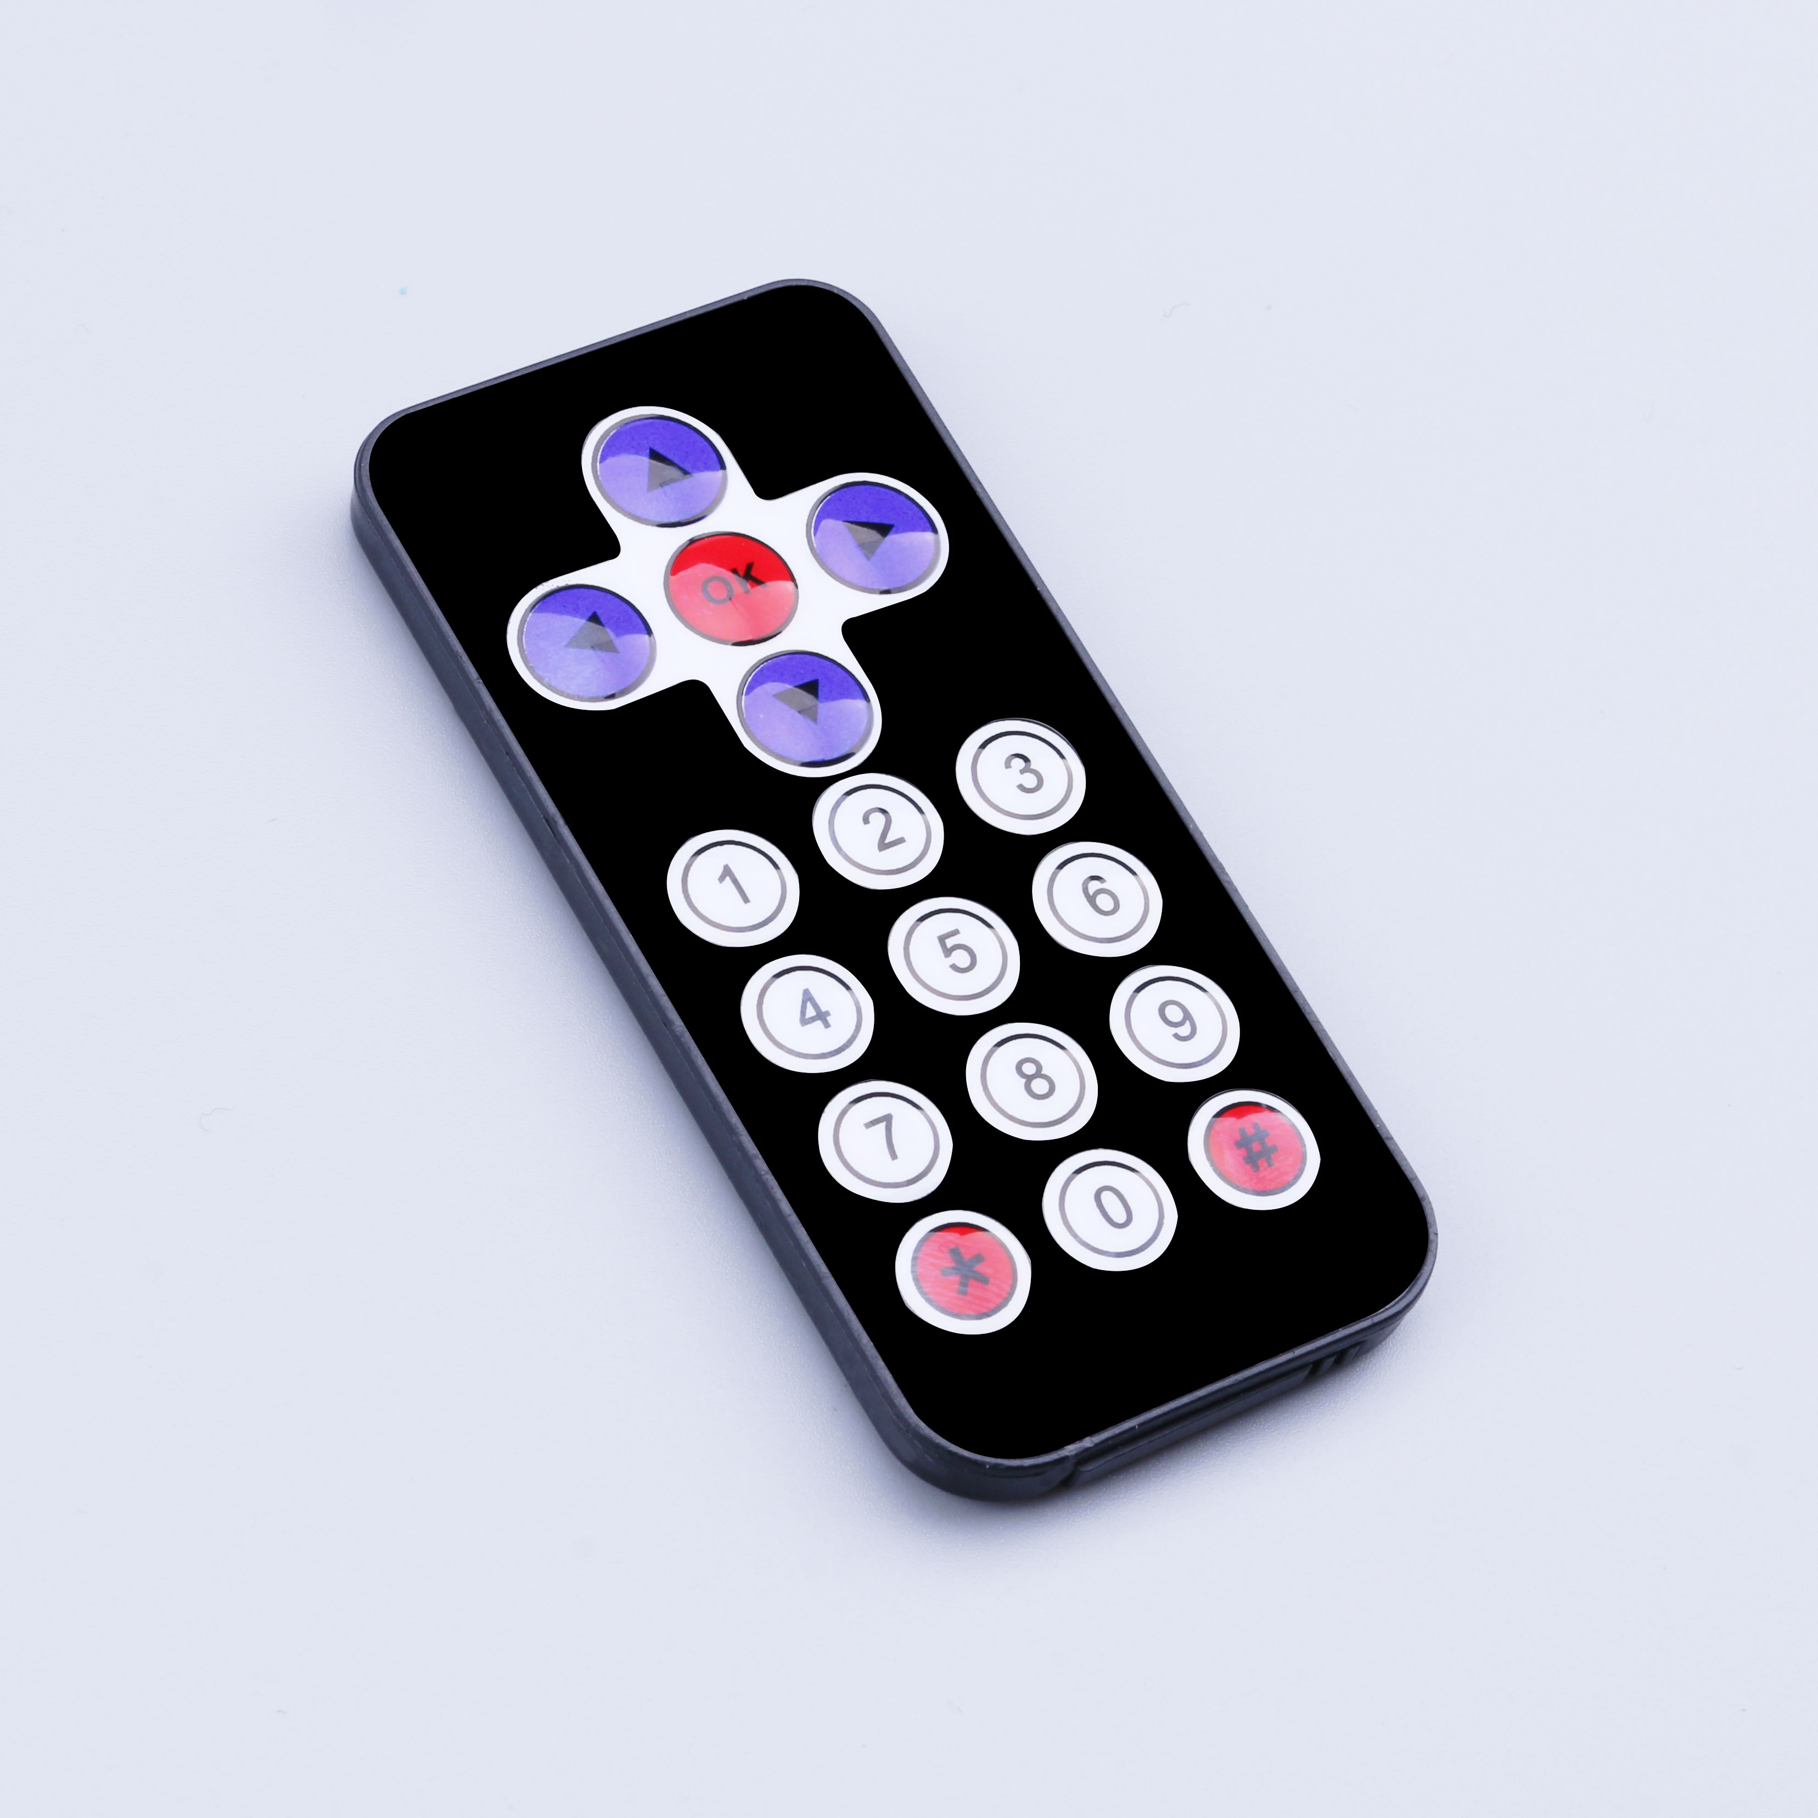
The latest wireless infrared remote controlling kits by mini ultra-thin infrared remote controlling and 38kHz infrared receiver module, mini slim infrared remote controlling with 17 function keys and launch the farthest distance up to 8 meters, is very suitable for the indoor control a variety of devices. The infrared receiving module can receive the remote controlling signal which is modulated by the standard 38 KHz, and the decoding operation of the remote controlling signal can be realized by programming the remote control signal.

Infrared remote controlling product parameters:
1. CR2025 environmental protection button battery, capacity 160mah
2 emission range: 8m above (specific and the surrounding environment, the receiver's sensitivity and other factors)
3 effective angle: 60 degree
4 surface materials: 0.125mmPET, effective life 20 thousand times.
5 stable quality, high cost performance
6 static current 3-5uA, dynamic current 3-5mA.

